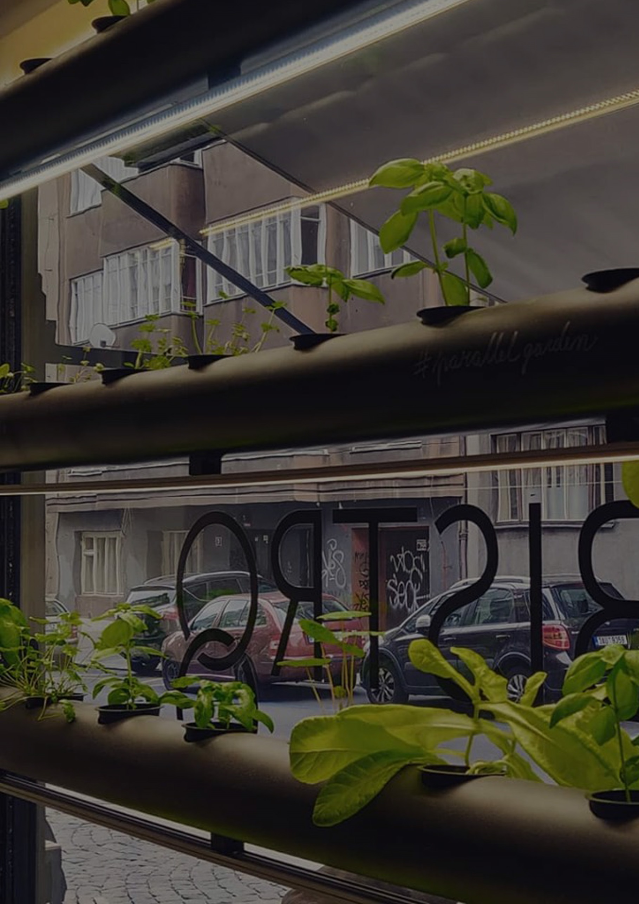**VERTICAL HYDROPONICS SYSTEM SEMIRAMIS BY PARALLEL GARDEN**

STEP BY STEP GUIDE



**INTRODUCTION**

This documentation serves as a guide how to construct vertical hydroponics system „Semiramis“ in accordance to the design of Parallel Garden research. You are invited to build your own hydroponics system using our current knowledge, and encouraged to share your experience, improvements, etc.

This technology works on the principle that water with nutrients circulates in growing channels while there is a stable water level inside them. Growing medium is slightly in touch with water and takes the water up to the plant at the beginning. Later roots are growing straight to the water.

This guide shows how to build 5 stories system with capacity of 25 plants. Approximate dimensions are 220x90x30cm.

**IMPORTANT!!!**

**While building, assembling, and adjusting your own system, please be cautious basic risks in order to avoid injury or damage. Keep the electric source even if it’s waterproof away from possible water leakage routes. The design works with 12V regime which is generally considered to be low-risk, but be careful anyway. Always make sure to unlpug the system from the electric socket while manipulating with the system in any way! Also make sure to use personal protective gear while building your system. You are likely get cut or burned if not paying enough attention or not using personal protective gear.**

**IMPORTANT!!!**

**Construction of the system requires multidisciplinary experience – you are about to build everything from scratch at your own risk – it’s not an installation guide of any specific product. If you lack experience with crafting, painting, soldering, hydraulics, electronics it is your responsibility to ask for professional help. Also feel free to contact us in case of any questions.**

**Please use our facebook page to do so:** [**https://www.facebook.com/parallelgarden**](https://www.facebook.com/parallelgarden)

**IMPORTANT!!!**

**It’s a good idea to read the whole document before you start shopping and building.**

**TOOLS**

Holder

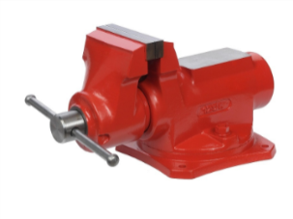

Measuring tape

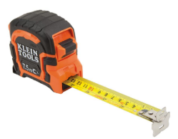

Pencil

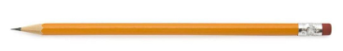

Pliers

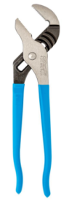

Miter saw

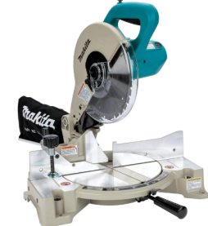

)

Drilling machine with heads for drilling holes of larger diameters

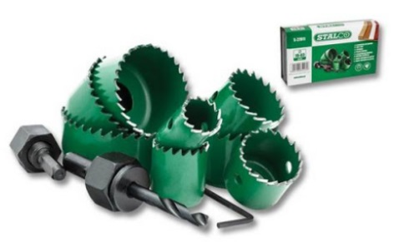

Solder, soldering iron

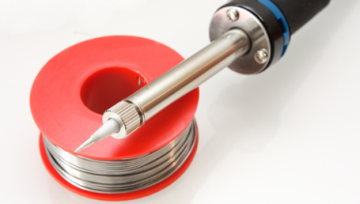

Scissors

Sand paper and rasper

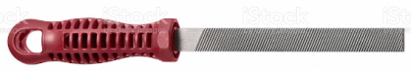

Iron saw

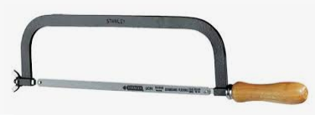

**MATERIALS – GROWING CHANNELS 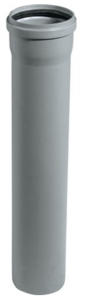5pcs**

5x Polypropylene HT pipes 1000 x 110mm

10x Reduction HT 110 – 50mm

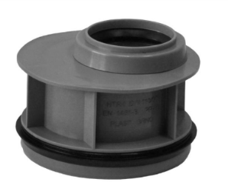

10x Lid HT 50mm

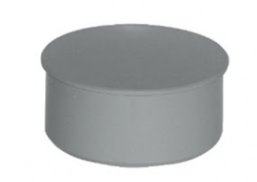

25x Hydroponics growing basket 8cm in diameter and 6cm deep with notable edge

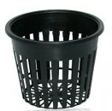

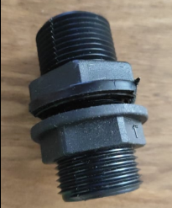6x 1“ bulk head fittings

15x Flat rubber sealing ring compatible with 1“ bulk head fittings

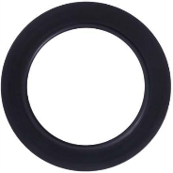

1x 1“ hose connector

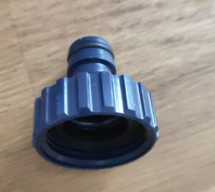

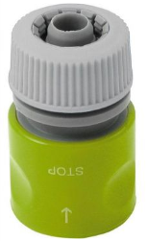1x ½ inch hose connector

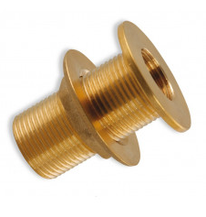5x ½ inch bulk head fitting with flat top

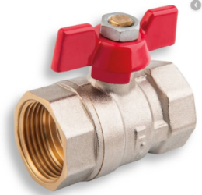5x ½ inch valve

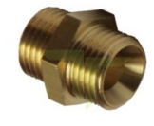5x ½“ fitting to connect the valve and hose fitting

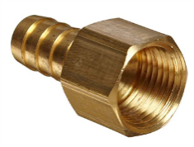5x ½“ hose fitting

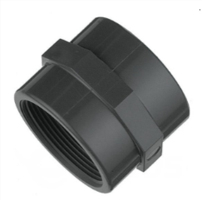5x 1“ pipe connector

5x 1“ hose fitting

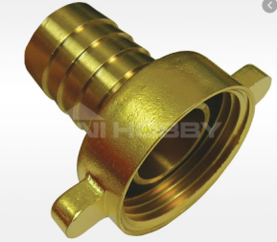

5x 1“ plastic hose of 30cm lenght

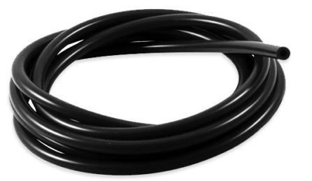

5x 1“ Wave seal ring

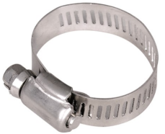

1x Teflon tape

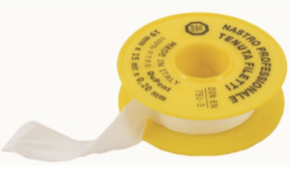

**STEP BY STEP GUIDE – GROWING CHANNELS**

**Preparation of the top growing channel**

1. Cut away the neck of the pipe so the pipe has total length 90cm.
2. Measure positions of plant holes:
3. Draw a straight line on the top of the pipe

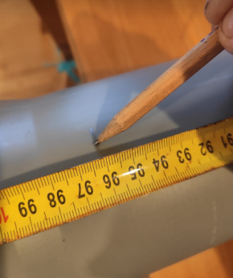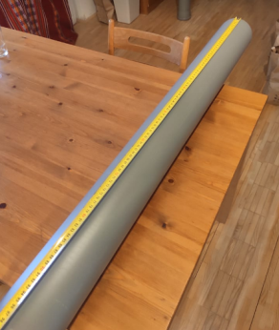

1. Measure centers of holes – start with the first one at 16cm distance from the edge, second one at 30cm, third at 45cm, fourth at 60cm, and fifth at 74cm.

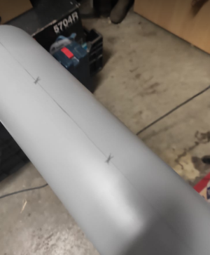

1. 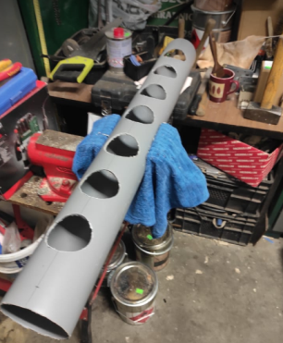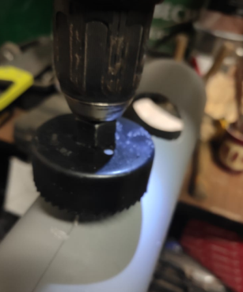Drill holes of necessary diameter (8cm) as per your outline.
2. 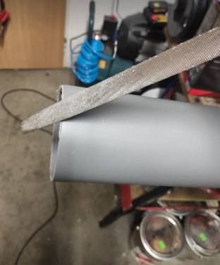Smoothen all edges with sandpaper or with rasper.
3. 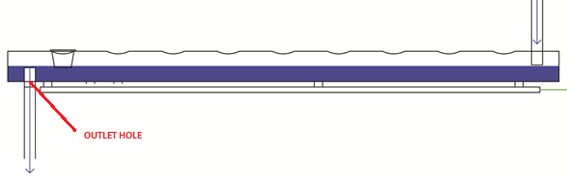Measure the center position of the outlet hole – it will be placed on the bottom of the pipe (opposite to your plant holes). Center will be placed 10cm from the end of the pipe.
4. Drill the outlet hole – the diameter should correspond with the size of 1“ bulk head fitting.
5. Measure the center position of the inlet hole – it will be placed in line with your plant holes (opposite to outlet hole). It will be placed 10cm from the other edge of the line than the outlet hole.

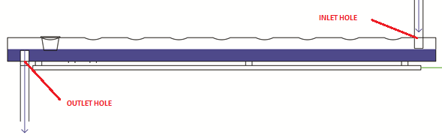

1. Drill the inlet hole – the diameter should correspond with the size of 1“ bulk head fitting
2. 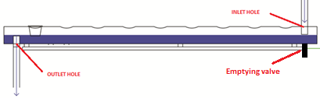Measure the center position of the emptying valve hole – it will be placed on the bottom of the growing channel opposite to the outlet hole. It will be placed 10cm from the end of the pipe as well.
3. Drill the emptying valve hole - the diameter should correspond with the size of 1/2“ bulk head fitting.
4. Smoothen all edges with the rasper or sandpaper.

**NOTE: Now it’s good time to paint the pipe if desired. Make sure to cover all holes so the paint don’t get inside the pipe. If it happens anyway it is recommended to remove any paint leftovers from the inside of the pipe.**

1. Assemble the inlet structure:
2. Install 1“ bulk head fitting into the inlet hole and tighten it slightly. Rubber sealing ring shall be placed inside the pipe.

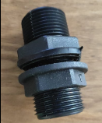

1. Install 1“ hose connector on the top of the bulk head fitting.

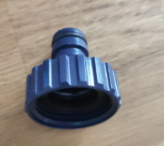

1. 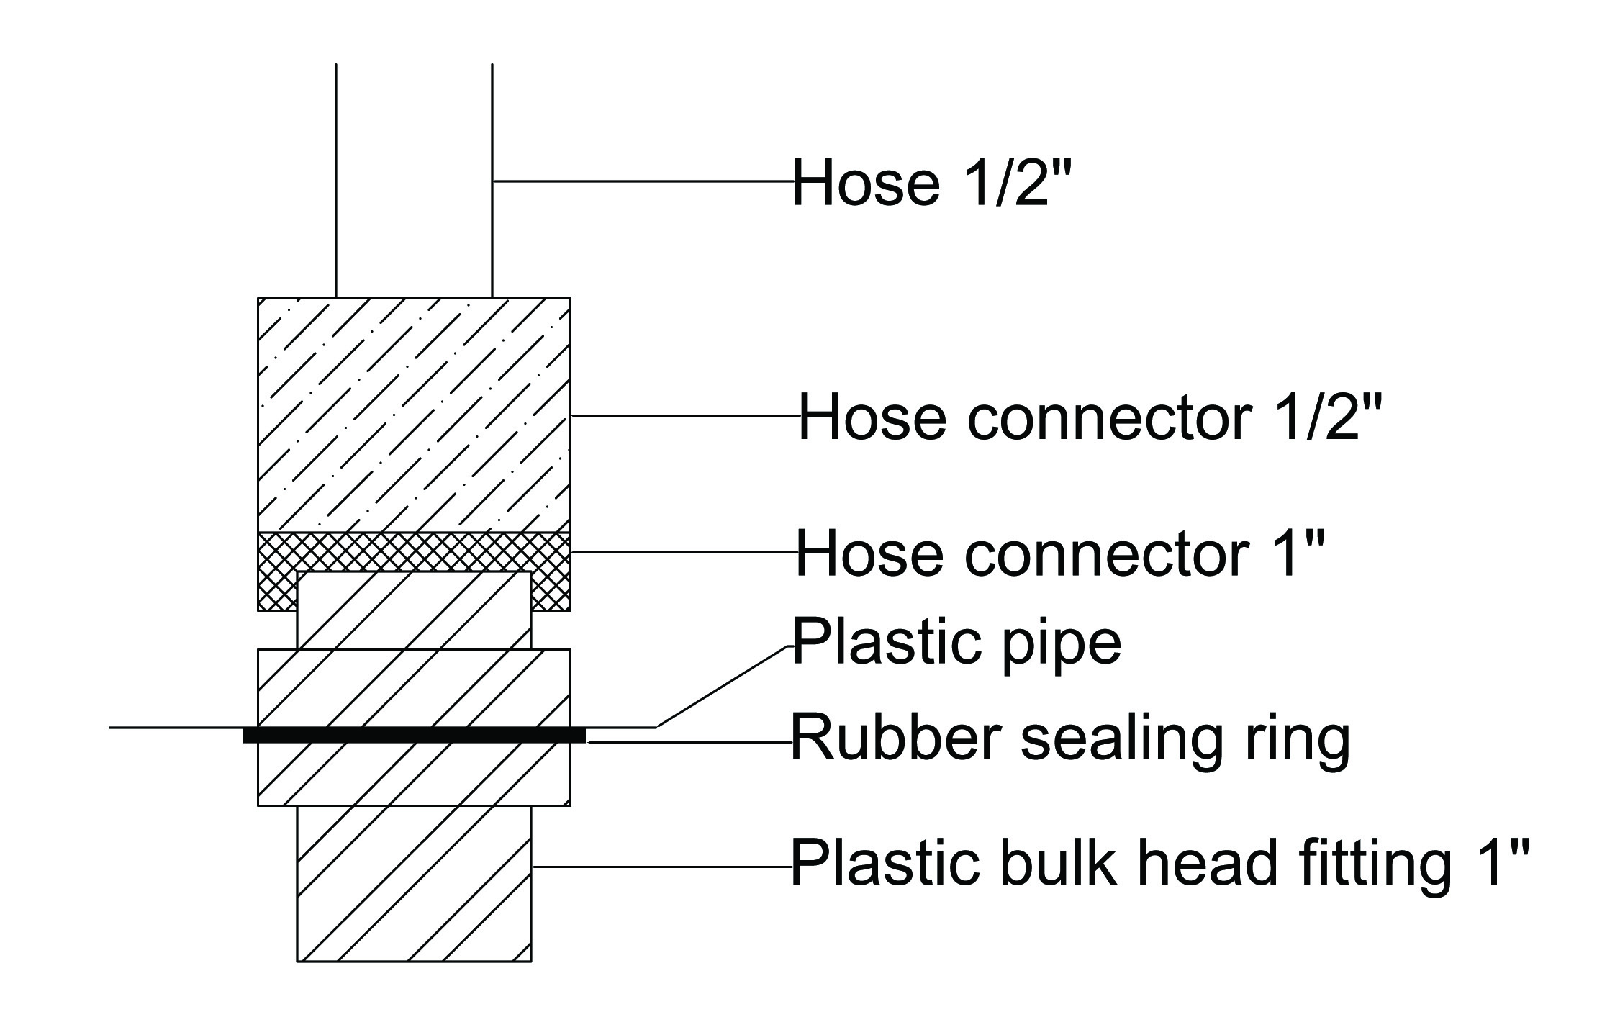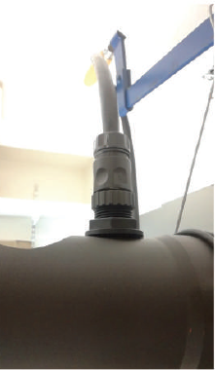This is how the setup of the main inlet should look like:
2. Assemble the outlet structure:
3. 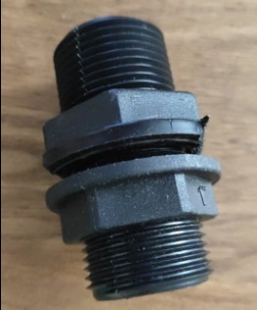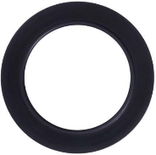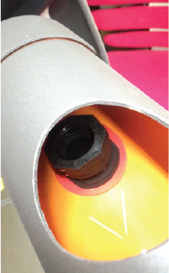Install 1“ bulk head fitting into the outlet hole, but place **total 3pcs of rubber sealing rings** on the bulk head fitting. These 3 pieces should be placed inside the pipe – they will ensure waterproof contact! Tighten the bulk head fitting well!
4. 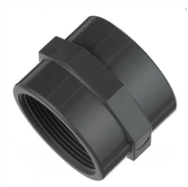Install 1“ pipe connector on the bulk head fitting inside the pipe. It will serve for regulation of the water level in the pipe – maybe this pipe connetor will need to be cut – you need the water level high enough so the growing baskest are slightly submerged (0,5cm).
5. 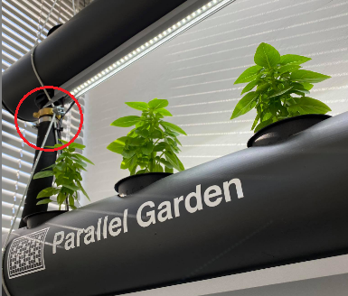Install 1“ hose fitting on the bottom of the 1“ bulk head fitting.
6. 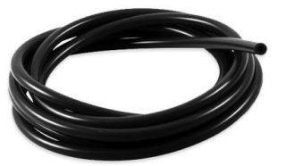Put 1“ black hose on the fitting and fix it with the wave seal ring.

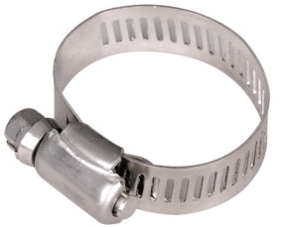

1. Setup of the outlet structure should look like this:
2. Assemble the emptying valve structure:
3. Install ½“ bulk head fitting with flat top into the hole and tighten well. Rubber sealing ring should be placed inside the pipe.

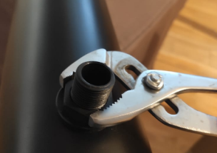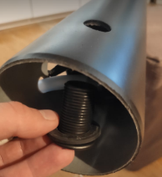

1. Install ½“ valve on the ½“ bulk head fitting. Use teflon tape to ensure the connection is waterproof.

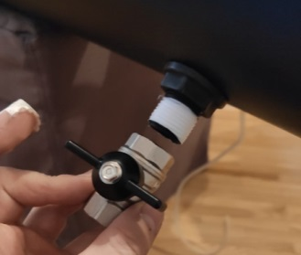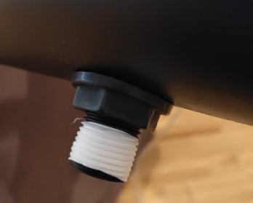

1. Install ½“ fitting into the valve. Use teflon tape again!



1. Install ½“ hose fitting onto the fitting in the valve. You may need to use teflon tape again.

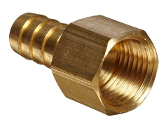

1. 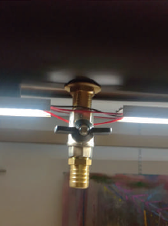Setup of the emptying valve structure should look approximately like this:

**Preparation of remaining growing channels**

1. Cut away the neck of the pipe so the pipe has total length 90cm.
2. Measure positions of plant holes:
3. Draw a straight line on the top of the pipe



1. Measure centers of holes – start with the first one at 16cm distance from the edge, second one at 30cm, third at 45cm, fourth at 60cm, and fifth at 74cm.



1. ****Drill holes of necessary diameter (8cm) as per your outline.
2. ****Smoothen all edges with sandpaper or with rasper.
3. ****Measure the center position of the outlet hole – it will be pplaced on the bottom of the pipe (opposito to your plant holes). It will be placed 10cm from the end of the pipe.
4. Drill the outlet hole – the diameter should correspond with the size of 1“ bulk head fitting.
5. Measure the center position of the inlet hole – it will be placed on the same line as your plant holes (opposite to outlet hole). It will be placed 10cm from the other edge of the line than the outlet hole.



1. Drill the inlet hole – the diameter should correspond with the size of 1“ hose.
2. Measure the center position of the emptying valve hole – it will be placed on the bottom of the growing channel opposite to the outlet hole. It will be placed 10cm from the end of the pipe as well.
3. Drill the emptying valve hole - the diameter should correspond with the size of 1/2“ bulk head fitting.
4. Smoothen all edges with sandpaper or rasper.

**NOTE: Now it’s good time to paint the pipe if desired. Make sure no paint will get into the pipe. I fit happens make sure to clean it off well.**

1. Assemble the outet structure:
2. 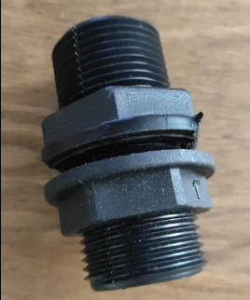Install 1“ bulk head fitting into the outlet hole, but place **total 3pcs of rubber sealing rings** on the bulk head fitting. These 3 pieces should be placed inside the pipe – they will ensure waterproof contact! Tighten the bulk head fitting well!
3. Install 1“ pipe connector on the bulk head fitting inside the pipe. It will serve for regulation of the water level in the pipe – maybe this pipe connetor will need to be cut – you nee the water level high enough so the groing baskest are slightly submerged (0,5cm).
4. Install 1“ hose fitting on the bottom of the 1“ bulk head fitting.
5. Put 1“ black hose on the fitting and fix it with the wave seal ring.



1. Setup of the outlet structure should look like this:
2. Assemble the emptying valve structure:
3. Install ½“ bulk head fitting with flat top into the hole and tighten well. Rubber sealing ring should be placed inside the pipe.



1. Install ½“ valve on the ½“ bulk head fitting. Use teflon tape to ensure the connection is waterproof.

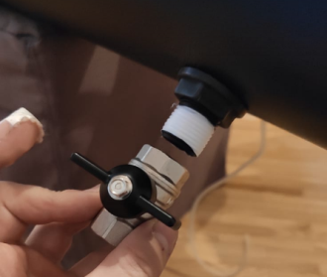

1. Install ½“ fitting into the valve. Use teflon tape again!



1. Install ½“ hose fitting onto the fitting in the valve. You may need to use teflon tape again.



1. Setup of the emptying valve structure should look approximately like this:

**MATERIALS LIGHTS**

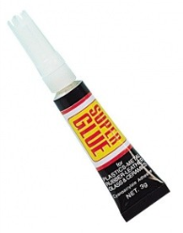1x Super glue – make sure you get a good one!

5m Double side glue tape – make sure you get a good one!

5x 1000mm aluminium twin bar for LED strips

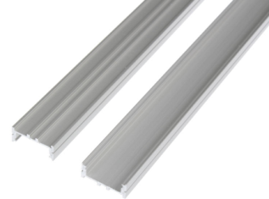

7m of LED strip (12V 20W/m 6500K 2000lm/m)

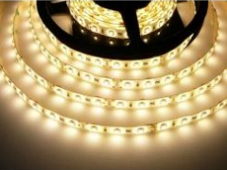

10m Cable with two cores diameter 0,75mm2

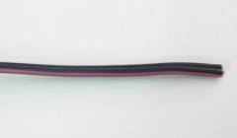

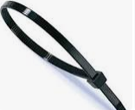2x Cable ties

1x Aluminium stick 1m long, 0,5cm diameter

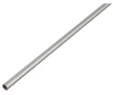

**PREPARATION OF GROW LIGHTS**

1. Measure 65cm on aluminium bars and cut them there.
2. Measure 10pcs of the LED strip of the same length as aluminium bars (65cm).
3. Glue LED strips on bars always in pairs (2 LED strips per bar). You may use few drops of super glue to make sure LED strips will hold well.
4. Cut 5 pcs of cables of following lengths: 2,5m, 2,2m, 1,9m, 1,6m, and 1,6m.
5. Split end of those cables and remove the insulation on all ends (about 0,5cm).

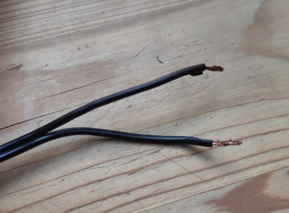

1. Solder those cables to the LED lights – cable need to be soldered always to one of the two LED strips inside the bar. Solder red core to the + contact and the black core to the – contact. Now one LED strip in your grow lights is working if connected to the source. (refer to illustrative picture below)

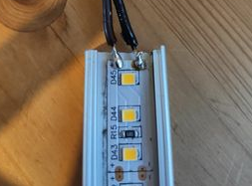

1. Cut 5 short pieces of the cable. Their length should be about 2cm.
2. Split them all apart so you will have 10 short single cables (5 black and 5 red).
3. Remove the insulation on their ends.

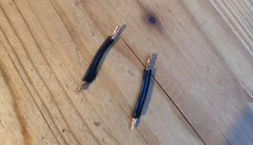

1. Now you will use these small cables to connect 2 LED strips within one bar. You will connect LED strips on the other side than the cable is attached. You need to connect + contacts of both LED strips and – contacts of both LED strips.

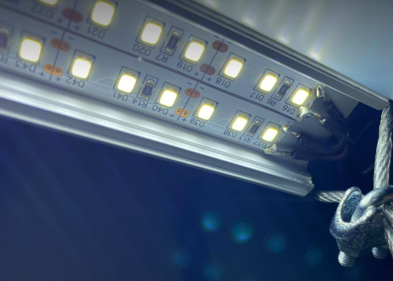

1. Your grow lights are ready to be installed now!

**GROW LIGHTS INSTALLATION**

!!! You will attach **4PCS** of your grow lights to the top 4 growing channels. Don’t attach any grow light onto the bottom of the lowest growing channel as there is NO NEED for that !!!

!!! Light with the longest cable will go to the top – don’t attach it to any growing channel. Light with the second longest cable will be attached to the top growing channel and so on !!!

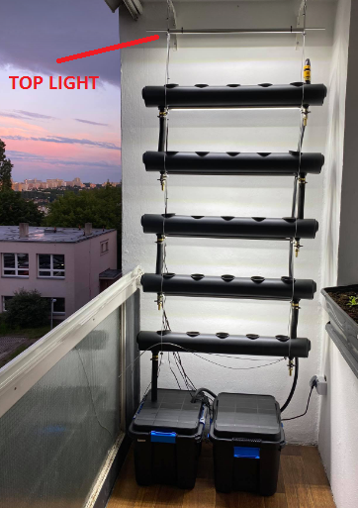

1. Use double side glue tape and glue it to the tops of your grow lights – place it all along, not in points but in the whole length.
2. Remove the top cover of the double side glue tape and add few drops of the super glue.
3. Glue the grow light to the growing channel. **IMPORTANT: Make sure to attach your grow lights in a way that cables will be on the same side of the system. It could make your life a bit difficult later on.**

**TOP LIGHT PREPARATION**

1. Top light is a bit different as it cannot be attached to any growing channel.
2. Cut the aluminium stick to the length of 90cm.
3. Use 2 cable ties and attach the grow light with longest cable onto the stick approximately in the middle.

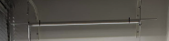

**MATERIALS – INSTALLATION OF THE SYSTEM**

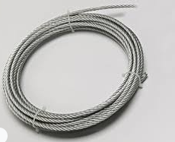2x 6m of the steel rope, diameter 3mm. Ideally find a rope that is coated in rubber – plain steel rope will scratch the paint of your growing channels.

12x steel rope lock

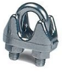

**INSTALATION OF THE SYSTÉM**

**!!! Serious or possibly fatal injuries might occur if the system is not fixed properly!!!**

**The system when filled with water is heavy and can cause crushing injuries if it falls. To prevent this, make sure you fix the system properly according to your chosen place of installation. This documentation cannot cover specific instructions needed to fix the system properly in your chosen place of installation because the circumstances may vary greatly depending on the material of wall/ceiling you chose to fix the system to. If you are not sure how the properly fix the system in place, contact your local specialized craftsman. Never let children around the system without supervision as they might try to climb on it or pull it which might cause the system to fall and crush them.**

1. 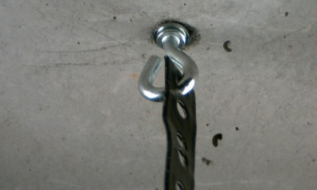You will need two anchoring points on your wall or on your ceiling. Together they should be able to carry at least 75kg of weight. These point shall be at least 2,3m high or higher. They should be placed about 65cm apart each other. Specific solution depends on the space properties, wall type, etc – we cannot provide detailed guide how to prepare anchoring points. It could look similar to this:
2. Once your anchoring points are ready take the steel ropes and put them through anchoring points – one rope – one anchor. Make sure both ends of each steel rope are of the same length.
3. Put the first lock on each steel rope and fix them right under the anchoring point.
4. Put second lock on each steel rope and fix them at the height of the top light (as high as possible or 2,3m high from the ground).
5. Put third lock on each steel rope and fix them approximately 40cm below the top light (1,9m above ground).
6. Place the top growing channel into the rope. Distance of the top of the growing channel from the top light should be 20cm – adjust the positions of both locks as necessary. Make sure the growing channel is placed horizontaly.
7. Continue with installation of remaining growing channels – top of each growing channel should be always 20cm below the grow light of the growing channel above.

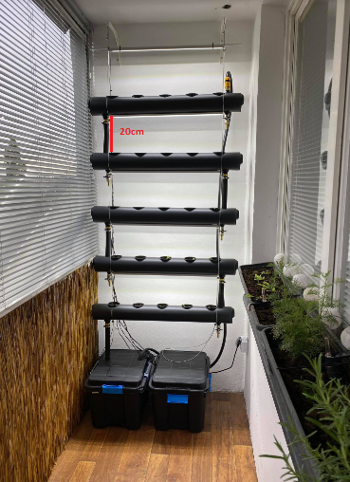

**WATERING SYSTEM MATERIALS**

1x Plastic box 50L with lid.

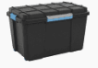

1x Submersible water pump strong enough to bring water up to 2m high – read the product description.

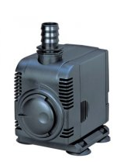

½ inch hose 2,5m black

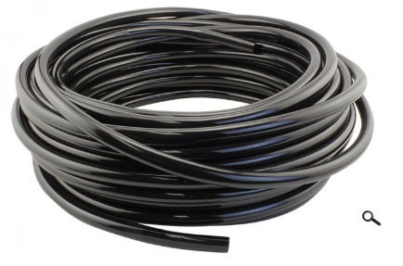

**INSTALLATION OF THE WATERING SYSTEM**

1. Attach the hose to the water pump – you may need various materials to attach it depending on the pump outlet size.
2. Take one plastic box and drill a hole into the lid on the left side approximately in the middle. Size of the hole should be greater than 1“ hose so it can get through. (box on the left)

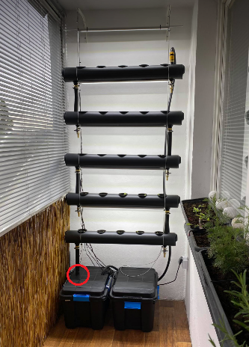

1. 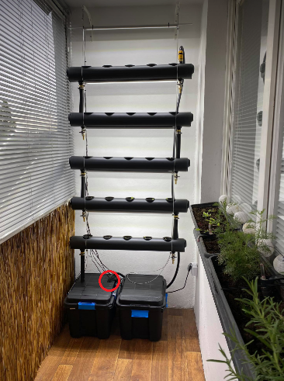Drill another hole of the same size into the lid on the opposite side.
2. Place the pump inside the box, put the ½“ hose and the water pump cable through the hole on the right.



1. Close the box with the lid, place it under the system, and put the outlet hose of your system through the left hole of the box. Excess water will be then collected inside the box.



1. Now connect the ½“ hose to the main inlet of the system.

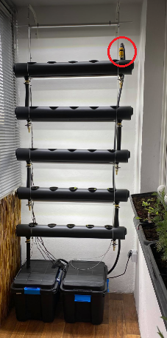

**MATERIALS – POWERING AND CONTROLLING SYSTEM**

**!!! MATERIALS YOU WILL BE ABLE TO FIND MAY BE DIFFERENT. IN CASE OF ANY DOUBTS OR IF YOU HAVE NO EXPERIENCE WITH ELECTRIC INSTALLATIONS ASK A PROFFESIONAL TO HELP YOU. NEVER TOUCH ANY CABLES AND CONNECTIONS WHILE THE SYSTEM IS PLUGGED TO THE SOCKET OR OTHER ELECTRICITY SOURCE. DAMAGES INCLUDING FIRE OR SERIOUS INJURIES MAY OCCUR IF THE LACK OF YOUR EXPERIENCE WILL BE IGNORED !!!**

1x Plastic box 50L with lid.



1x 12V 240W IP67 electric adaptor

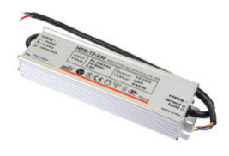

2x Analog timer

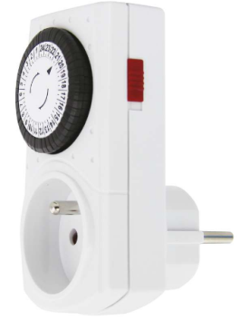

1x Electric socket connector male (220V 16A)

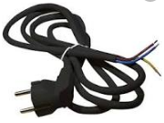

3x Wago cable connector (2 locks, 300V, 20A)

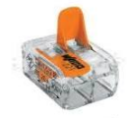

2x Cable connector bar with 6 locks

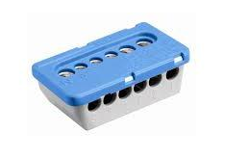

2x Wago cable connector (3 locks, 300V, 20A)

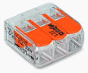

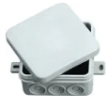1x Small waterproof electric box

2x Cable ties

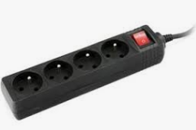1x Extension cord with 4 sockets at least

**POWERING AND CONTROLLING SYSTEM INSTALLATION**

**!!! MATERIALS OR STANDARDS IN VARIOUS COUNTRIES MAY BE DIFFERENT. IN CASE OF ANY DOUBTS OR IF YOU HAVE NO EXPERIENCE WITH ELECTRIC INSTALLATIONS ASK A PROFFESIONAL TO HELP YOU. NEVER TOUCH ANY CABLES AND CONNECTIONS WHILE THE SYSTEM IS PLUGGED TO THE SOCKET OR OTHER ELECTRICITY SOURCE. DAMAGES OR SERIOUS INJURIES MAY OCCUR IF THE LACK OF YOUR EXPERIENCE WILL BE IGNORED !!!**

1. Take the plastic box 50L and drill a hole in the back side. Place this hole at least 20cm above the bottom, diameter should be about 8cm.
2. Take small electric box, and connect electric socket connector with the electric adaptor inside – use wago connectors. Then close the box completely and lock it if possible. (illustrative picture below)



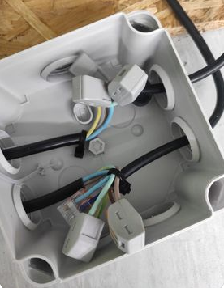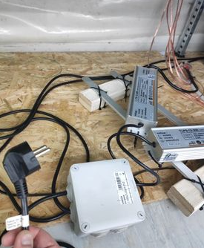

1. Put cables leading from your lights into the large box through the hole you have drilled. Put your power adaptor inside as well.
2. 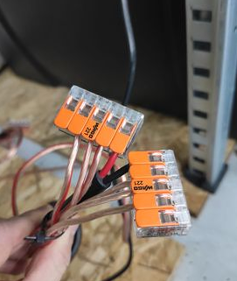Connect cables from your lights to the cables that go from the power adaptor – red cables from your lights will go to „+“ power source cable, and the other ones to the „-“ power source cable. Refer to the illustrative picture below.
3. Now your lighting system is ready.
4. Bring the water pump power cord into the box through the hole in the back.
5. Bring the extension cord with 4 sockets into the box through the hole in the back as well.
6. Plug two timers into sockets of the extension cord. Set one timer for lights – it should be on 14 hours every day (we usualy start at 7:00 and stop at 21:00). Set the second timer for the pump – it should be switched on idealy every hour for 10min – depending on possibilities of the timer. If you need the pump to be off during night it should be ok. If you cannot switch the pump on often enough it helps to put bubbler into the water tank to keep the water fit.
7. Plug light source to the Light timer, and the water pump power cord to the Pump timer.
8. !!! AT THIS POINT YOUR SYSTEM IS POWERED AND YOU CANNOT MANIPULATE WITH IT, NOR TOUCH CABLES, ETC !!! THIS APPLIES AS LONG AS THE SYSTEM IS POWERED !!! Plug the extension cord with 4 sockets into the power.
9. Now your system is ready for operation.

Refer to following drawing while installing the system:

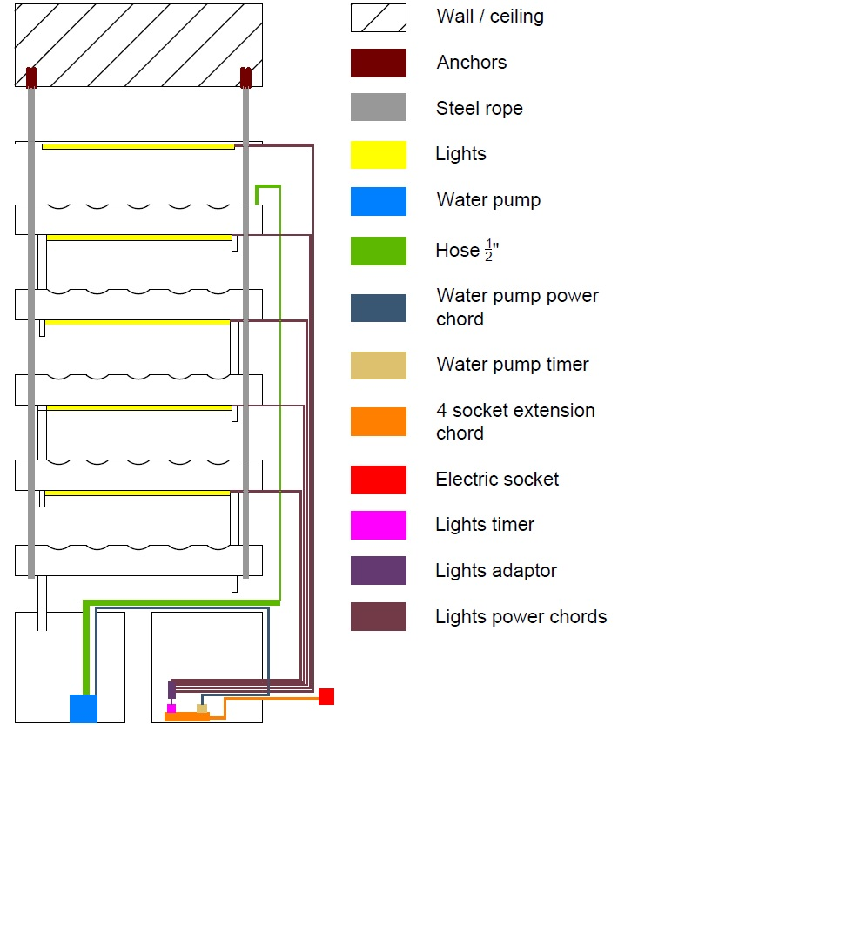

¨

**TERMS OF USE OF VERTICAL HYDROPONICS SYSTEM SEMIRAMIS BY PARALLEL GARDEN AND TERMS OF DESIGNATIONS AND BRAND REFERENCES**

**THESE TERMS APPLY TO USAGE OF THE NAME “SEMIRAMIS”, “PARALLEL GARDEN”, PARALLEL GARDEN LOGO (“PROTECTED DESIGNATIONS”), REFERENCES TO THESE PROTECTED DESIGNATIONS AND TO USAGE OF THE VERTICAL HYDROPONICS SYSTEM SEMIRAMIS CONSTRUCTION SOLUTION (“SEMIRAMIS CONSTRUCTION”).**

**ANY USE OF THE PROTECTED DESIGNATIONS AND SEMIRAMIS CONSTRUCTION SOLUTION MUST FOLLOW TERMS AND CONDITIONS SET OUT BELOW.**

**1) Terms of use of Vertical Hydroponics system Semiramis by Parallel Garden**

THE DESIGN OF THE VERTICAL HYDROPONICS SYSTEM SEMIRAMIS BY PARALLEL GARDEN IS NOT THE SAME AS THE NAME "SEMIRAMIS", THE "PARALLEL GARDEN" BRAND, THE "PARALLEL GARDEN" LOGO, AS ANY OTHER NAME THAT REFERS TO SEMIRAMIS AND/OR PARALLEL GARDEN ("PROTECTED DESIGNATIONS"). FOR DISPOSAL OF THE CONSTRUCTION SOLUTION OF THE VERTICAL HYDROPONICS SYSTEM SEMIRAMIS BY PARALLEL GARDEN, DIFFERENT CONDITIONS APPLY THAN FOR THE USE OF THE DESIGNS, NAMES AND BRAND DESCRIBED IN THE PREVIOUS SENTENCE. THESE RULES ARE SET OUT BELOW IN THIS DOCUMENT.Semiramis Construction (i.e. the technical solution, design and documentation) may be used by everyone at their own discretion, incorporated into other solutions and further published in its original or derived form with following limitations.

When using the Semiramis Construction, you must follow these Terms and the Vertical Hydroponics System Semiramis by Parallel Garden Step by Step Guide, available at: <https://github.com/ParallelGarden/Semiramis/blob/main/documentation/StepByStepGuideSemiramis1.3.pdf> ("Step by Step Guide"). Any deviations from the Semiramis Construction (e.g. any alterations or changes in the technical solution or different assembly procedure) are considered as derivatives and are your own product.

The step by step guide is provided "as is" and any express or implied warranties, including, but not limited to, the implied warranties of merchantability and fitness for a particular purpose are disclaimed. In no event Parallel Garden or its team members or advisors shall be held liable for any direct, indirect, incidental, special, exemplary, or consequential damages (including, but not limited to, procurement of substitute goods or services; loss of use, data, or profits; or business interruption) however caused and on any theory of liability, whether in contract, strict liability, or tort (including negligence or otherwise) arising in any way out of the use of the Step by Step Guide, even if advised of the possibility of such damage.

If you publish or provide the Semiramis Construction and/or Step by Step Guide or other documentation and/or any parts thereof in any way to another person or entity, you must always publish the full text of the Step by step Guide content without any derivatives, HOWEVER WITHOUT ANY REFERENCE TO THE PROTECTED DESIGNATIONS, unless you have obtained the previous written consent from Parallel Garden. Any derivatives including modifications, recommendations, advice, comments and any other interventions that may affect the content or meaning of the wording of the Step by Step Guide or other documentation must be clearly marked, attributed to you and strictly separated from the original content.

**2) Terms of designations and brand references**

**ALL RIGHTS TO THE PROTECTED DESIGNATIONS ARE RESERVED TO PARALLEL GARDEN TEAM OR THEIR RESPECTIVE OWNERS OR AUTHORS.**

UNDER NO CIRCUMSTANCES IS ANYONE AUTHORIZED TO USE THE NAME "SEMIRAMIS", THE "PARALLEL GARDEN" BRAND, THE "PARALLEL GARDEN" LOGO, AS ANY OTHER NAME THAT REFERS TO SEMIRAMIS AND/OR PARALLEL GARDEN ("PROTECTED DESIGNATIONS") IN CONNECTION WITH OR REFERENCE TO ANY SOLUTION, DEVICE, PRODUCT, GOODS, SERVICE, TRADEMARK, NAME, PERSON, ENTITY, OR IN ANY OTHER WAY, UNLESS ALLOWED BY PARALLEL GARDEN TEAM IN WRITTING. IN THE EVENT OF A BREACH OF THIS PROHIBITION, ALL AVAILABLE CLAIMS ARISING OUT OF THIS BREACH MAY BE ENFORCED.

If you are interested in any use of any of the Protected Designations, please contact us to ask for the written consent to the Protected Designations via chat located at: https://www.facebook.com/parallelgarden.